Evaluation of high-entropy (Cr, Mn, Fe, Co, Ni)-oxide nanofibers and nanoparticles as passive fillers for solid composite electrolytes

Asia Patriarchi^{1,#}, Claudia Triolo^{2,3,#}, Luca Minnetti¹, Miguel Ángel Muñoz-Márquez^{1,3},
Francesco Nobili^{1,3,}*, Saveria Santangelo^{2,3,}*

¹ Chemistry Division, School of Science and Technology, University of Camerino, 62032 Camerino, Italy
² Dipartimento di Ingegneria Civile, dell’Energia, dell’Ambiente e dei Materiali (DICEAM), Università “Mediterranea”, Via Zehender, Loc. Feo di Vito, 89122 Reggio Calabria, Italy
³ National Reference Center for Electrochemical Energy Storage (GISEL), Consorzio Interuniversitario Nazionale per la Scienza e Tecnologia dei Materiali (INSTM), 50121 Firenze, Italy

Supplementary Materials

Synthesis and physicochemical properties of the fillers
Materials
High-entropy oxide (HEO) to be used as nanofillers in the solid polymer electrolyte preparation were produced by utilizing chromium (III) acetate hydroxide, manganese(II) acetate tetrahydrate, iron (II) acetate, cobalt (II) acetate tetrahydrate, and nickel (II) acetate tetrahydrate as Cr, Mn, Fe, Co and Ni sources.
Citric acid monohydrate C₆H₈O (purity: 98%; CAS No. 5949-29-1, Sigma Aldrich) was used as a complexing agent for the synthesis of fillers via the conventional sol-gel (SG) method. In the synthesis via electrospinning (ES), polyacrylonitrile (PAN, 150000 g mol⁻¹, 99.9%, Sigma Aldrich, CAS No. 25014-41-9) and N,N-dimethylformamide (DMF, anhydrous, 99.8%, Sigma Aldrich, CAS No. 68-12-2) acted as a polymer and as a solvent, respectively.
Syntheses
To obtain HEO nanoparticles (NPs), stoichiometric amounts of Cr, Mn, Fe, Co and Ni sources were dissolved in 30 g water, one at a time (Figure S1a). After magnetic stirring, 3.5 g citric acid was added and the resulting mixture was further stirred until a gel was formed. After drying at 80 °C overnight, the gel was calcined in static air (Figure S1b.1) under the selected conditions (Table S2).
The precursor solution to obtain HEO nanofibers (NFs) was prepared via sol-chemistry, dissolving the five metal salts, one at a time (Figure S1a), in a 7.14 wt% PAN in DMF solution under continuous stirring. Total amount of metals was 38.46 wt% relative to PAN. After loading into a 20 mL syringe equipped with a 40 mm long, 0.8 mm gauge stainless steel needle, the solution was fed at 1.13 µL h⁻¹ rate. ES was operated at 25 ± 1 °C and 40−45% relative air humidity (Figure S1b2.1), under a DC voltage of 15−16 kV. The distance between the tip of the needle and the grounded aluminum collector was 15 cm. After drying at room temperature (RT) overnight, the membrane was calcined in a muffle furnace (Figure S1b2.2) under the selected conditions (Table S2). In both syntheses, temperature was increased at a rate of 10 °C min⁻¹ and calcination was followed by rapid cooling out of the furnace to promote the formation of defects, oxygen-deficiency and porosity [1–3].

Table S1. Purity, CAS numbers, suppliers and stoichiometric amounts of the Cr, Mn, Fe, Co and Ni salts utilised as Cr, Mn, Fe, Co and Ni sources in the preparation of HEO fillers.
Metal source | Purity / % | CAS No. | Supplier | Amount / g
Cr₃(OH)₂(CH₃COO)₇ | 98 | 39430-51-8 | Sigma Aldrich | 0.0881
Mn(CH₃COO)₂·4H₂O | 99 | 6156-78-1 | Sigma Aldrich | 0.1078
Fe(CH₃COO)₂ | 95 | 3094-87-9 | Sigma Aldrich | 0.0765
Co(CH₃COO)₂·4H₂O | 99 | 6147-53-1 | Sigma Aldrich | 0.1096
Ni(CH₃COO)₂·4H₂O | 98 | 6018-89-9 | Sigma Aldrich | 0.1095

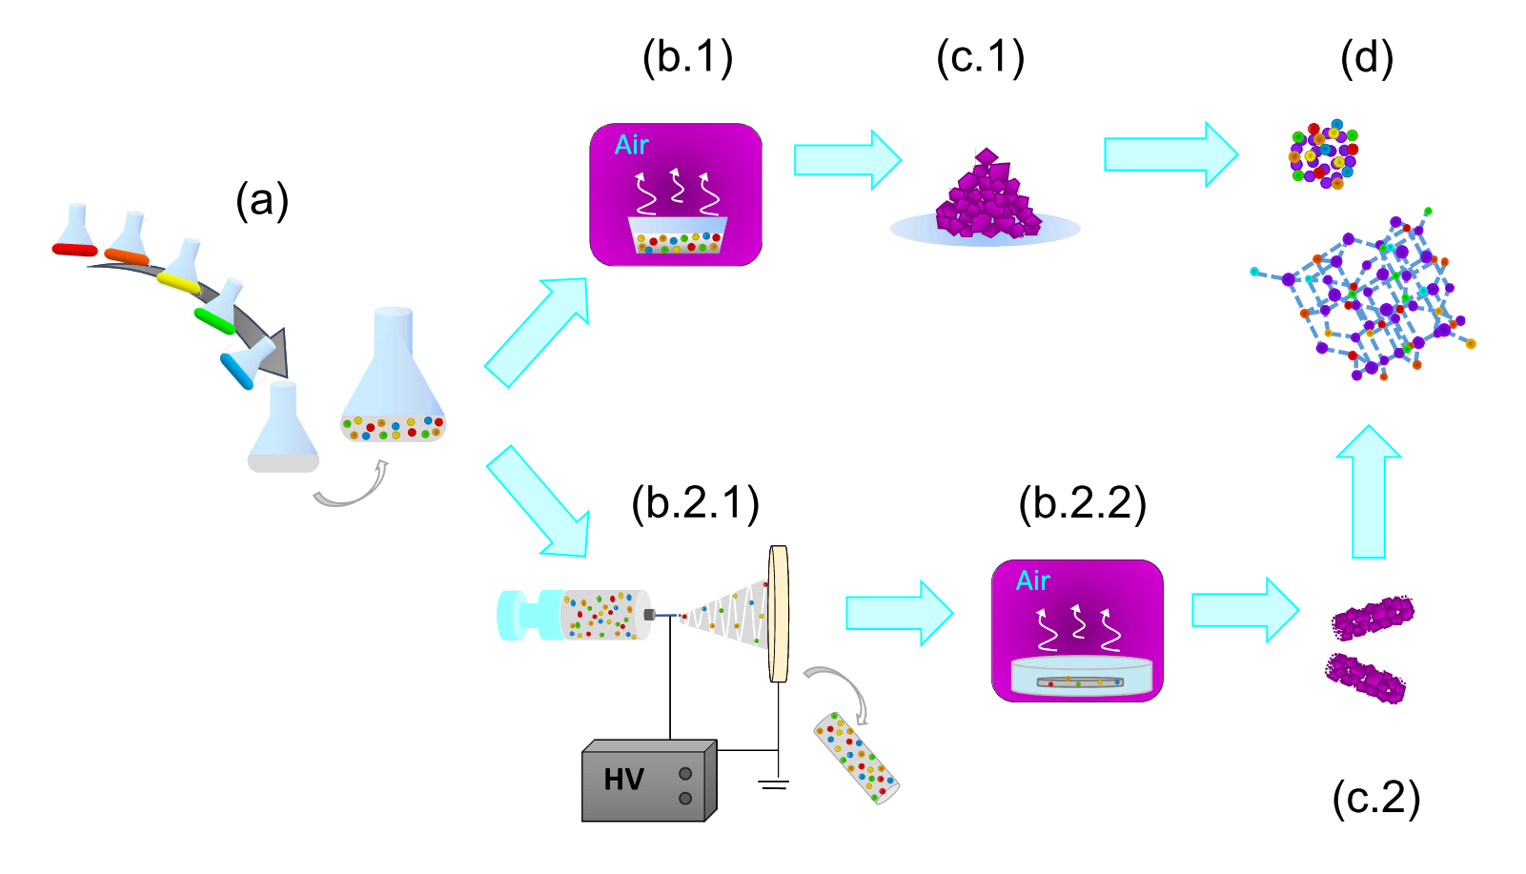
Figure S1. Schematic description of the procedure for the syntheses of HEO fillers: (a) addition of the selected reagents, one at a time, to the solvent(s) resulting in a homogeneous solution containing an equimolar combination of five metals; (b.1) calcination and (c.1) HEO-nanoparticles obtained via sol-gel method; (b.2.1) electrospinning, (b.2.2) calcination and (c.2) as-obtained HEO-nanofibers; (d) spinel structure of the HEO-grains constituting nanoparticles and nanofibers.

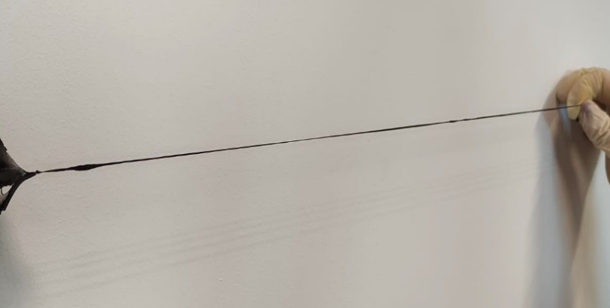
Figure S2: Good elasticity and tensile strength of the PEO LiTFSI (EO/Li 21:1) 10 wt% ES800/0.5 membrane.

Morphology of the electrospun fillers

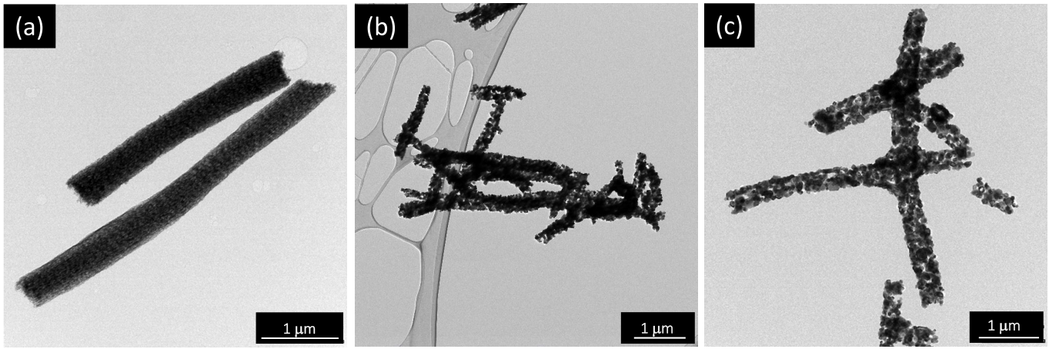
Figure S3. TEM images of electrospun fillers (a) ES400/2, (b) ES800/0.5 and (c) ES800/2.

Phase(s), spatial uniformity and inversion degree of the oxide

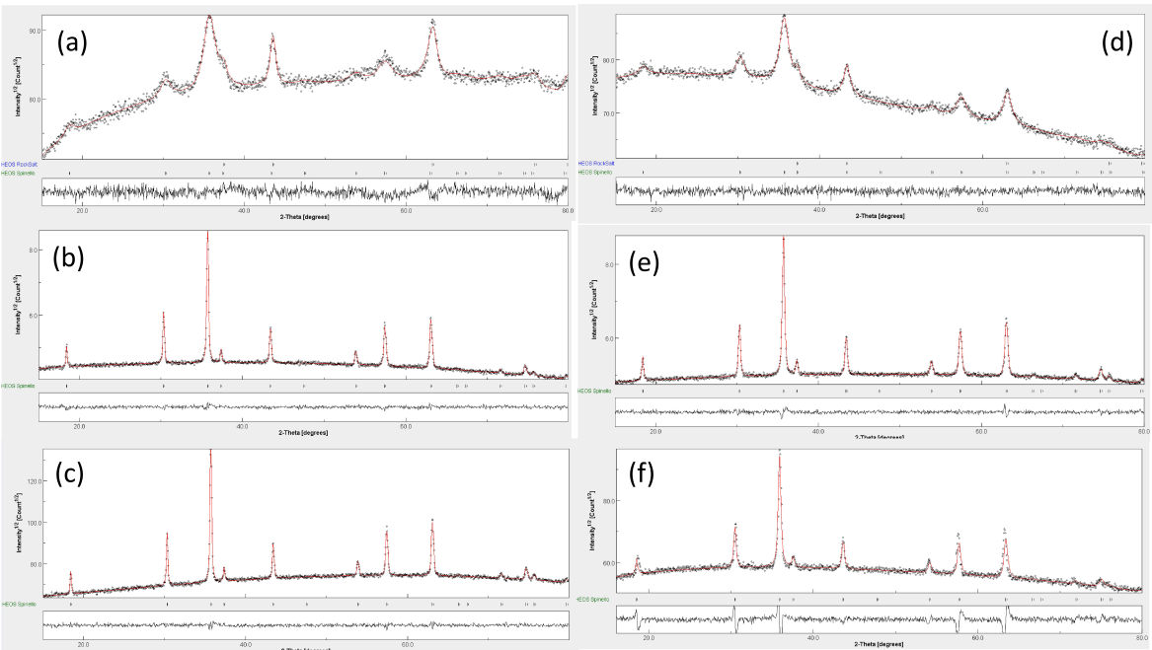

Figure S4. Results of Rietveld refinements from XRD data. Diffractograms refer to samples (a) SG400/2, (b) SG800/0.5, (c) SG800/2, (d) ES400/2, (e) ES800/0.5 and (f) ES800/2.

Table S2. Results of Rietveld refinements from XRD data. RHEO and SHEO stand for rock-salt- and spinel-structured HEO phases. In fillers produced by calcination at 400 °C, where RHEO and SHEO phases co-exist, the mean size of HEO crystallites (d_{HEO}) is evaluated as weighted average of the crystallite sizes of the two phases.
Sample | Phase | Rel. weight / % | a / nm | Crystal size / nm | Microstrain | d_{HEO} / nm
SG400/2 | SHEO | 77.4% | 0.834 | 7.45 ± 0.23 | 6 10^{–3} | 11.7
SG400/2 | RHEO | 22.6% | 0.415 | 26.2 ± 3.7 | 4 10^{–3} | 11.7
SG800/0.5 | SHEO | 100 | 0.833 | 70.3 ± 1.0 | 9.1 10^{–4} | 70.3
SG800/2 | SHEO | 100 | 0.833 | 74.6 ± 1.2 | 8.8 10^{–4} | 74.6
ES400/2 | SHEO | 91.6 % | 0.834 | 8.27±0.14 | 2.66 10^{–6} | 9.2
ES400/2 | RHEO | 8.4% | 0.417 | 18.9 ± 2.8 | 4.16 10^{–5} | 9.2
ES800/0.5 | SHEO | 100% | 0.833 | 47.6 ± 0.6 | 1.25 10^{–3} | 47.6
ES800/2 | SHEO | 100% | 0.835 | 60.9 ±4.0 | 8.3 10^{–4} | 60.9

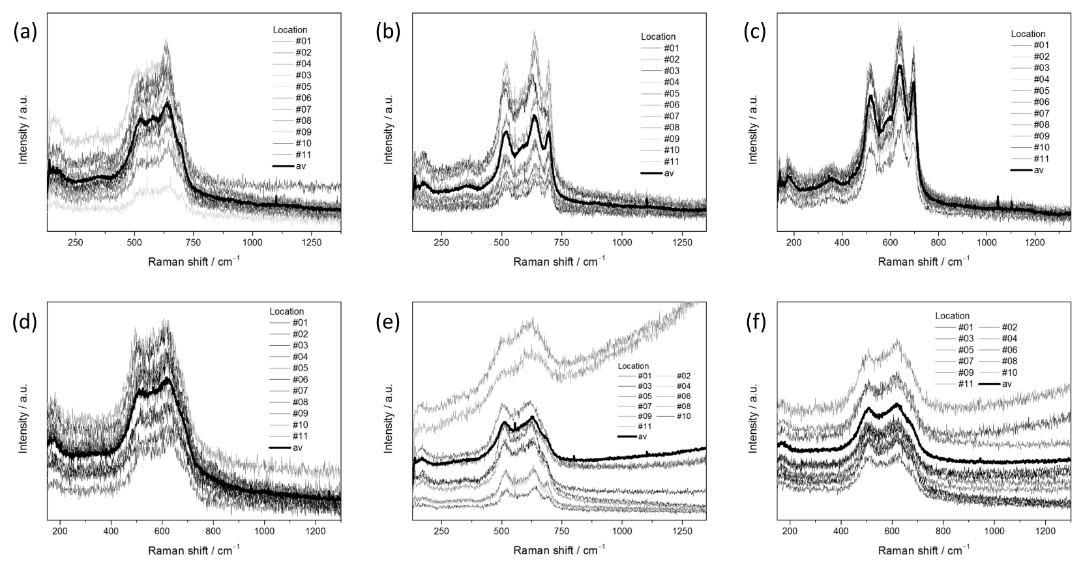
Figure S5. Micro-Raman spectra, as measured at different random locations, within each specimen. Spectra refer to samples (a) SG400/2, (b) SG800/0.5, (c) SG800/2, (d) ES400/2, (e) ES800/0.5 and (f) ES800/2.

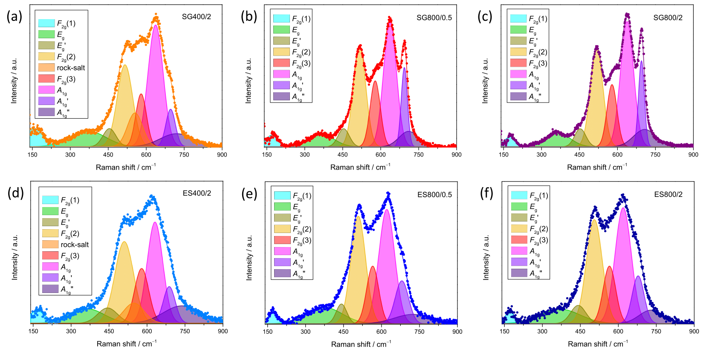
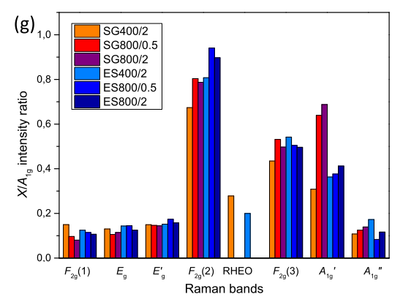
Figure S6. (a−f) Fits of the averaged micro-Raman spectra of samples (a) SG400/2, (b) SG800/0.5, (c) SG800/2, (d) ES400/2, (e) ES800/0.5 and (f) ES800/2 to Gaussian bands. (g) Relative (to the A_{1g}-band) intensities.

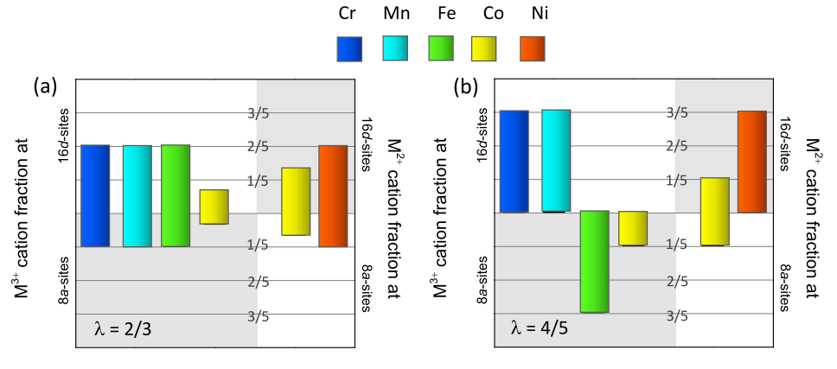

Figure S7. (a) Completely random and (b) equilibrium distribution of cations for spinel-structured (Cr,Mn,Fe,Co,Ni) HEO [4]. The inversion degree (λ) of the spinel lattice [M²⁺_{1−λ}M³⁺_{λ}]_{8a}[M²⁺_{λ}M³⁺_{2−λ}]_{16d}O₄ is also reported.

Electrochemical properties of the PEO/HEO/LiTFSI SCEs

Table S3. Results of the non-linear least squares fitting to the EIS curves using the equivalent circuit method: intrinsic resistance of the electrolyte (R_{E}), interphase resistance (R_{I}) and overall resistance (R_{O}). Activation energy (E_{A}), as resulting from the fit of the Arrhenius plot for T < T_{M}, and transference number of the electrolyte (τ⁺). The reported data refer to PEO/HEO/LiTFSI SCEs with fixed PEO/LiTFSI molar ratio (21:1) and filler content (10 wt%).
Filler | R_{E} / Ω | R_{I} / Ω | R_{O} / Ω | τ⁺ | E_{A} / kJ mol⁻¹
SG400/2 | 52.9 | 998 | 1050.9 | 0.28 | 53.6±0.2
SG800/0.5 | 115 | 671 | 786 | 0.35 | 47.3±0.2
SG800/2 | 77 | 798 | 875 | 0.33 | 51.13±0.18
ES400/2 | 24.4 | 2740 | 2762.4 | 0.29 | 55.7±0.2
ES800/0.5 | 22.5 | 163 | 185.5 | 0.37 | 43.06±0.14
ES800/2 | 25.6 | 198 | 223.6 | 0.34 | 51.4±0.2

Table S4. Results of SEM/EDX compositional analysis on PEO/HEO/LiTFSI SCE containing ES800/0.5 filler.
Element | Atomic concentration / %
Carbon | 57.2
Oxygen | 28.8
Fluorine | 10.0
Sulfur | 3.4
Chromium | 0.2
Nickel | 0.1
Manganese | 0.1
Cobalt | 0.1
Iron | 0.1

Figure S8: SS/ES800 0.5/SS Nyquist plots used for the determination of SCE ionic conductivity.
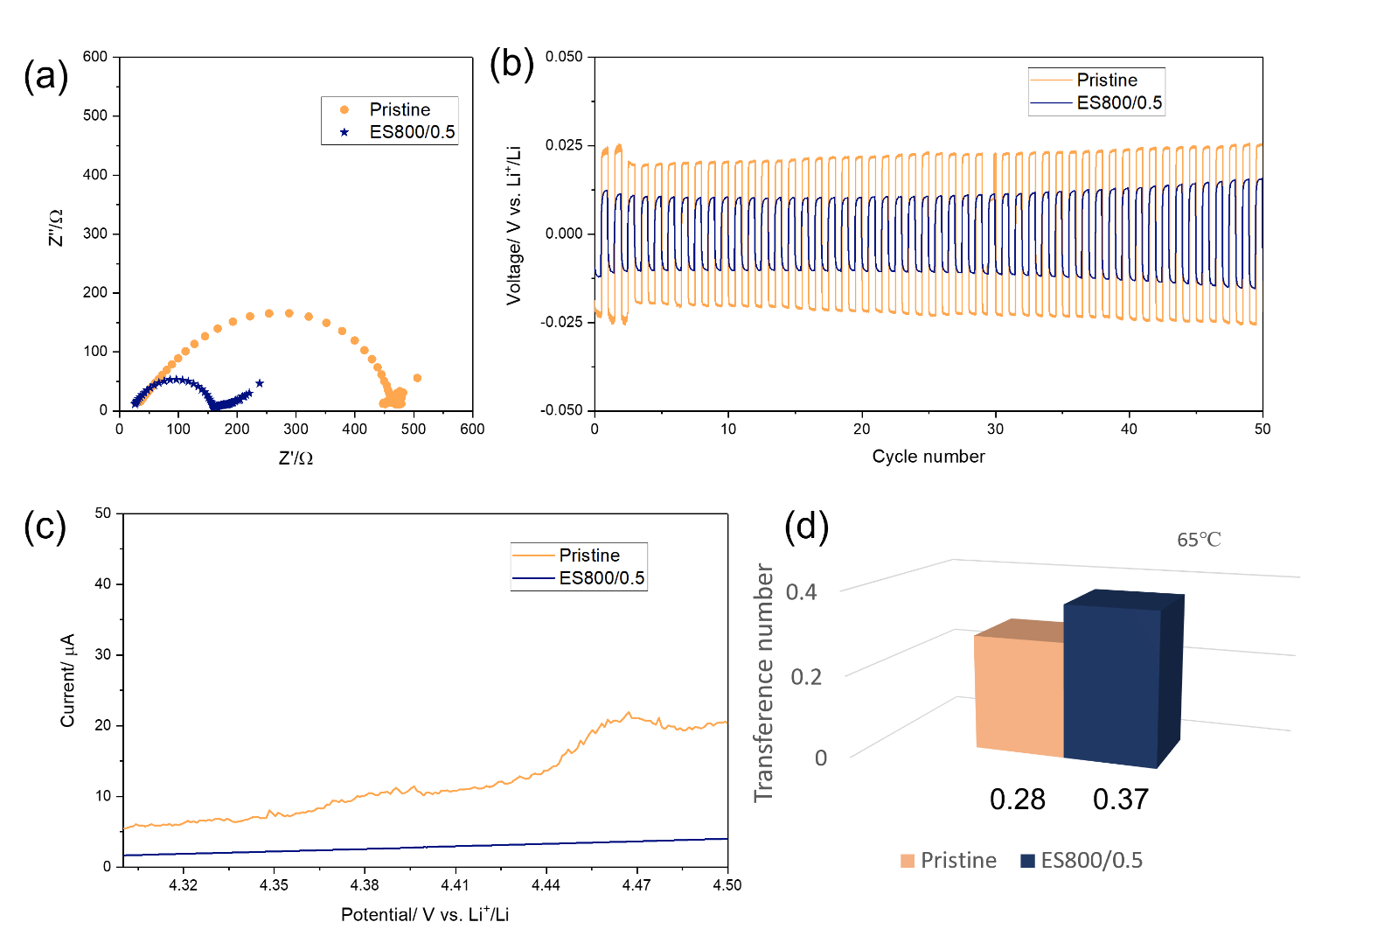
Figure S9: Comparison between the pristine electrolyte (PEO/LiTFSI) and the best performing composite electrolyte (PEO/ES800/0.5/LiTFSI). (a) Nyquist plots at OCV and (b) stripping and plating performance recorded in a symmetric Li/SCE (or pristine)/Li cell at 65°C. (c) Anodic stability window obtained for the pristine electrolyte and the SCE in Li/SCE (or pristine)/WE cell configuration at 65°C. (d) Lithium-ion transference number obtained from CA and PEIS measurament in symmetric cell configuration at 65°C.

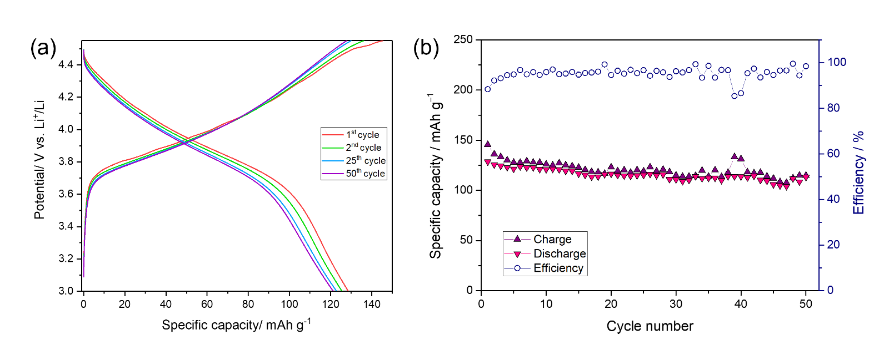
Figure S10. (a) Galvanostatic profiles and (b) cycling performance of Li/SCE (10% ES800/0.5)/NMC cell and relative efficiency.

Refecrences

[1] A. V. Malyshev, A.B. Petrova, A.N. Sokolovskiy, A.P. Surzhikov, Effect of fast cooling on defects level, microstructure and magnetic properties of LiTiZn ferrite ceramics, Mater Chem Phys 227 (2019). https://doi.org/10.1016/j.matchemphys.2019.02.022.
[2] M. Hilal Elhousseini, T. Isık, Ö. Kap, F. Verpoort, N. Horzum, Dual remediation of waste waters from methylene blue and chromium (VI) using thermally induced ZnO nanofibers, Appl Surf Sci 514 (2020). https://doi.org/10.1016/j.apsusc.2020.145939.
[3] F. Pantò, Z. Dahrouch, A. Saha, S. Patanè, S. Santangelo, C. Triolo, Photocatalytic degradation of methylene blue dye by porous zinc oxide nanofibers prepared via electrospinning: When defects become merits, Appl Surf Sci 557 (2021). https://doi.org/10.1016/j.apsusc.2021.149830.
[4] C. Triolo, K. Moulaee, A. Ponti, G. Pagot, V. Di Noto, N. Pinna, G. Neri, S. Santangelo, Spinel-Structured High-Entropy Oxide Nanofibers as Electrocatalysts for Oxygen Evolution in Alkaline Solution: Effect of Metal Combination and Calcination Temperature, Adv Funct Mater 34 (2024). https://doi.org/10.1002/adfm.202306375.

# A.P. and C.T. contributed equally to this work. * Corresponding authors: E-mail addresses: francesco.nobili@unicam.it (F. Nobili), saveria.santangelo@unirc.it (S. Santangelo).

